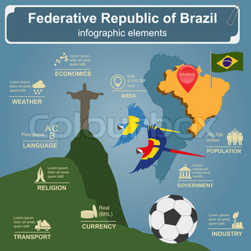**Criteria for Second Delivery of Project: Infographics about a country that is not Colombia.**

There are the characteristics your infographics should have:

1. It must be A4 size
2. It must be printed
3. It should contain a brief historic reference of the country in a small paragraph that does not exceed the 100 words and that it is not the main or central element of the infographics.
4. It should contain information about: the structure of its government, its infrastructure, branches of public power, geography, natural resources and biodiversity, economy, culture, language and SOME CURIOUS DATA you found about the country.
5. It must be put, pasted or framed on a hard surface in order that they can be easily put on a wall for being exhibited.
6. In the back of the hard surface you put it in, draw the table below, which is the assessment grid we will use to give you a score.

|  |  |
| --- | --- |
| **ITEM** | **SCORE** |
| Content: Does it have it all? |  |
| Relevance: Is that information useful? |  |
| Punctuality: Did I give it on time? |  |
| Design: Is it attractive and organized? |  |
| Language use: Does it reflect a good level of English? |  |
| **TOTAL** |  |